**What’s it all about?**

Biology is the Study of Life. We have 5 big topics to cover this year. They include:

* Cells
* Genetics
* Evolution
* Organ Systems
* Ecology

Lessons are designed to be fun, challenging, educational, full of hands-on learning and to meet the needs of **ALL** students!

**How am I going to be graded?**

Grades are based on participation, assignments, activities, laboratories, bell work and tests. It is **YOUR RESPONSIBILITY** to check you grades regularly. **PLEASE ASK** if you ever have a question about your grade.

93-100%=A 90-92%=A- 87-89%=B+

83-86%=B 80-82%=B- 77-79%=C+

73-76%=C 70-72%=C- 67-69%=D+

63-66%=D 60-62%=D-

**Retake/Revisions Policy**

Revisions will be required for any test score earned below 80%.

Retakes will be given at teacher discretion. Students must request the retake and demonstrate effort in learning the material before retest will be granted.

**What do I need?**

You will be given a biology book within the first few days of class that is yours to keep. **Bring it EVERY DAY, along with your writing utensil!**

There is a $10 lab fee for biology. This fee covers your textbook and expenses associated labs. Please pay the fee at the finance office and bring me the receipt.





Biology

Ms. Curtis

***E-mail:*** [***caryl.curtis@washk12.org***](mailto:kerry.moody@washk12.org)



**What is expected of me in this class?**

My expectations of you are fairly straight forward:

1. Come to class and be on time!

**There is not a way to “make-up” everything that you miss when you are absent.**

1. Be prepared, work hard, have a good attitude, & treat everyone with respect.
2. Have FUN ☺

*3 or more absences (excused or unexcused) a quarter is considered excessive and may require that students meet with the teacher.*

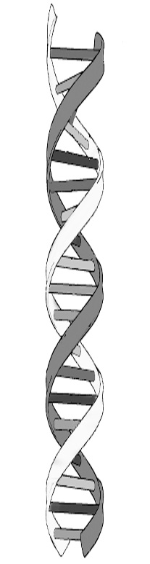

**How can I earn a good grade?**

What grade do you want to earn—an A, a D? It is all up to you! Please know that I am here to help you! **I want you to succeed!!** I will be available for extra help each day most lunches and after school until 3:30. If these times don’t work for you, let me know and we will find a time that will.

**Lab Policy**

Labs are designed to be fun and engaging. Safety protocol and instructions must be followed at all times. Failure to do so will result in a **zero** for the lab.

**What happens each day in class?**

**Bell Work/Bell Quiz**

We will do an activity at the beginning of each class. Points are earned by attending class, arriving on time, completing the bell work activity/quiz for the day, and actively participating in class.

**Cell Phone Policy**

We will, on occasion, use cell phones for an assignment or activity in class. Otherwise, *cell phones are not to be seen or heard*.



**How can I see what I’ve missed when I’m absent?**

I keep a class blog that highlights what we do in class each day. Please visit this website when you are absent before you ask me what you missed!

[**http://pvhscurtis.weebly.com/**](http://pvhscurtis.weebly.com/)

If you are absent, it is up to you to get your missed work in a TIMELY manner!!