Biology Bellwork 10/2 and 10/5 Name__________________________
How many different kinds of atoms does an element contain?
A) six
B) two
C) four
D) one

How can enzymes benefit chemical reactions, as shown in this energy diagram?
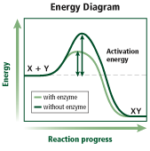
A) lowering activation energy
B) raising activation energy
C) slowing reactions
D) increasing the amount of product

Biology Bellwork 10/2 and 10/5 Name__________________________
How many different kinds of atoms does an element contain?
A) six
B) two
C) four
D) one

How can enzymes benefit chemical reactions, as shown in this energy diagram?
A) lowering activation energy
B) raising activation energy
C) slowing reactions
D) increasing the amount of product

