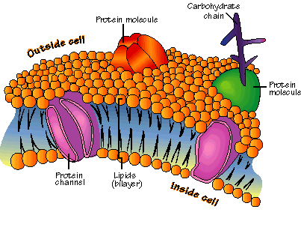
Cell Membranes and Movement Notes Name______________

Substances move in and out of the cell in order for the cell to function
properly and maintain homeostasis.

_______________ -- the ability of an organism to maintain a constant internal balance even when the conditions around it change.

Cell (plasma) membrane
- Cells need an inside & an outside…
  - separate cell from its environment
  - cell membrane is the______________

IN OUT
Food Waste

Products

- Cell needs materials ______ and products or waste ______
Cell membrane controls what gets in or out
Need to allow _________ materials — but not all — to pass through the membrane
semi-permeable
___________________________________________
Membrane is made of special kind of lipid
inside cell
outside cell
- ___________________
- “split personality”
Membrane is a double layer
- _________________

Crossing the cell membrane
What molecules can get through the cell membrane directly?
- ________ and __________ can pass directly through
Cell membrane channels
Need to make “doors” through membrane
- ____________ ____________ allow substances in & out
- ______________ channels allow specific material in & out
- H2O channel, salt channel, sugar channel, etc.
Proteins act as doors in the membrane
- ____________ to move specific molecules through cell membrane
Molecules move from high to low
Diffusion
- move from ________ to ________ concentration
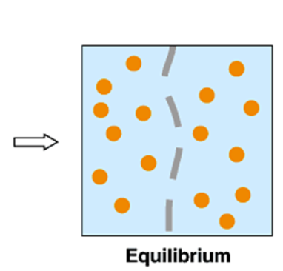

Move from HIGH to LOW concentration
- ___________ transport
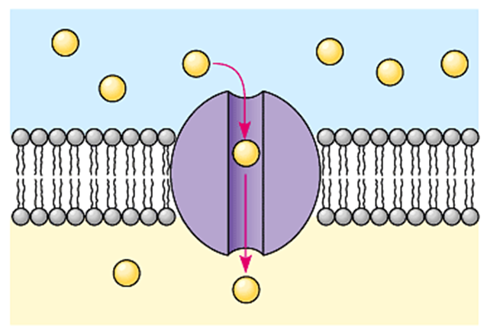
- _____ energy needed
Facilitated Diffusion
- Move from HIGH to LOW through a ____________
directly through membrane
- ________ diffusion
- _____energy needed
help through a protein channel
- ___________ diffusion (with help)
- _____ energy needed

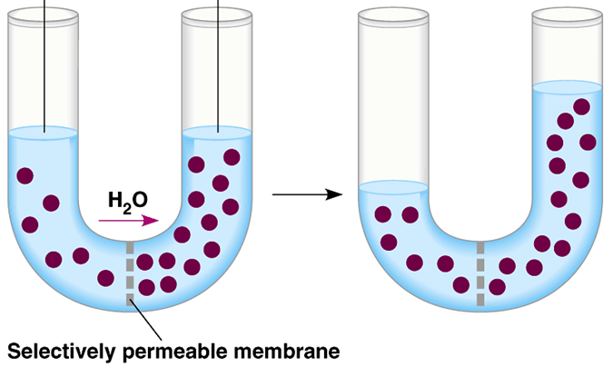
____________
Movement of Water Across
Cell Membrane
Water is very important, so we talk about water separately
- Osmosis
- ______________ of water from HIGH concentration of water to LOW concentration of water
- across a _______________________ membrane

Cell survival depends on _________________ water uptake & water loss
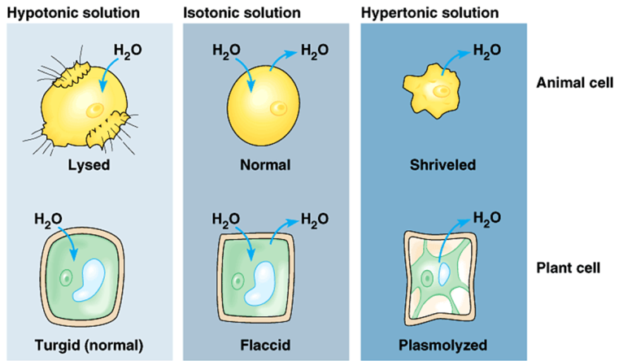

Keeping right amount of water in cell
Hypotonic
- ________ concentration of water around cell
- cell __________ water
- Cell swells
Example
a cell in fresh water

Hypertonic Solution
- _______ concentration of water around cell
- cell loses water
- Cell ____________
Example
Cells in salt water

Active transport
- Cells may need molecules to move ___________ concentration “hill”
- need to pump “uphill”
- from LOW to __________ using energy
- requires ____________ (ATP)
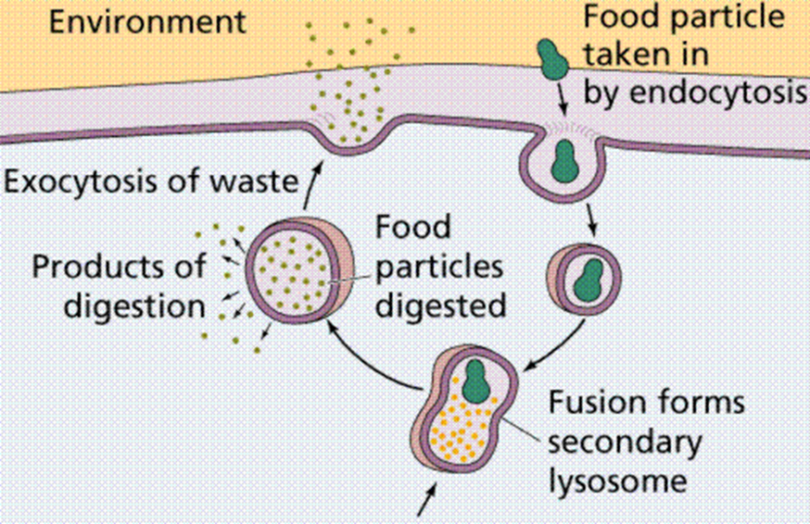
Endocytosis and _____________ is the mechanism by which very large molecules (such as food and wastes) get into and out of the _________
- Food is moved ________ the cell by ___________________
- Wastes are moved ________ of the cell by Exocytosis

