Name ___________________________________________ Date __________________________ Period ________

# Taxonomy: Life's Filing System - Crash Course Biology Video

1. What is Taxonomy?
2. If we go back far enough every living thing is related to every living thing, meaning we all have what?
3. The trick of taxonomy is basically figuring out what?
4. Who is the Swedish scientist that developed this classification system because he saw that the current naming system would collapse and was too confusing?
5. The method of naming and classifying organisms that Linnaeus adopted was based on . . .
6. Although taxonomy has come a long way since Linnaeus, we are still using the same taxa groups to classify. List these groups below:

BROADEST: MOST INCLUSIVE

SPECIFIC: LEAST INCLUSIVE

_________________________________

__________________________________________________________________

_________________________________

_________________________________

_________________________________

_________________________________

1. We are also using binomial nomenclature, the use of a 2 part name for every species. What 2 names do we use to name an organism?
2. Now that we have new technology and can classify using genetic analysis and structure, we have stuck a new taxa above Linnaeus’s kingdom. What is this more broad taxa called?
3. What are the domains 3 we have?
4. Under the domain Eukarya, we have 4 kingdoms. List the 4 Eukaryotic Kingdoms below:
5. Plants, or Plantae, are autotrophs. Meaning they can do what?
6. The Protist Kingdom contains both autotrophs and heterotrophs. There are 3 types of protists: ___________________-like, _______________________ - like, & _________________________-like.
7. Fungus has cell walls like plants, but instead of being made of cellulose, they are made of _____________________, which is the same material in the exoskeleton of a beetle.
8. Animals are _________________________ and are _______________________________, meaning we spend a lot of time hunting down food because we can’t make it ourselves.

**PART 1 – TAXONOMIC RELATIONSHIPS -** Use this chart to answer questions 1-7 below.

|  |  |  |  |  |  |  |
| --- | --- | --- | --- | --- | --- | --- |
|  | **House Cat** | **Red Fox** | **Dog** | **Wolf** | **Gopher** | **Fly** |
| **Kingdom** | Animalia | Animalia | Animalia | Animalia | Animalia | Animalia |
| **Phylum** | Chordata | Chordata | Chordata | Chordata | Chordata | Arthropoda |
| **Class** | Mammalia | Mammalia | Mammalia | Mammalia | Mammalia | Insecta |
| **Order** | Carnivora | Carnivora | Carnivora | Carnivora | Rodentia | Diptera |
| **Family** | Felidae | Canidae | Canidae | Canidae | Geomyidae | Muscidae |
| **Genus** | *Felis* | *Vulpes* | *Canis* | *Canis* | *Thomomys* | *Musca* |
| **Species** | *domesticus* | *fulva* | *familiaris* | *lupus* | *bottae* | *domestica* |

1. What kind of animal is *Vulpes velox*? How do you know?

2. What is the complete classification of *Vulpes velox*?

3. Which two animals are most closely related? Explain.

4. Why is a dog more closely related to a red fox than a house cat?

5. Which taxon would have more species, an order or a family?

6. Which taxon includes only organisms that can successfully interbreed?

7. If two organisms belong to the same family, what other taxonomic groups do the organisms have in common?

**PART 2 – READING A CLADOGRAM** -- Use the cladogram to answer questions 1-6 on part 2.

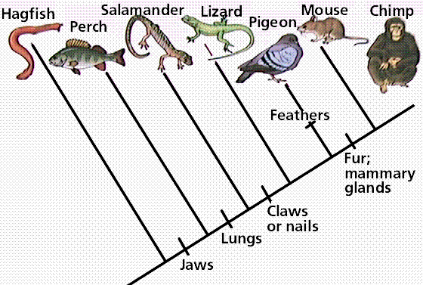

1. Which animals have claws or nails?
2. Which animals have jaws?
3. How many derived characteristics separate hagfish form chimps and what are they?

1. How many derived characteristics separate perch from pigeons and what are they?
2. Which derived characteristic(s) do salamanders and mice have in common?
3. Which two organisms are more closely related hagfish and perch or perch and lizards? How did you make your conclusion?

**PART 3 – MAKING A CLADOGRAM**

1. Fill in the following table. Mark an “X” if an organism has the trait.

|  |  |  |  |  |
| --- | --- | --- | --- | --- |
|  | cells | legs | 6 legs | wings |
| Worm |  |  |  |  |
| Spider |  |  |  |  |
| Carpenter Ant (black) |  |  |  |  |
| Fly |  |  |  |  |

*\*spiders have 8 legs, ants and flies have 6*

1. Add each of these organisms to the cladogram below: worm, spider, ant, fly

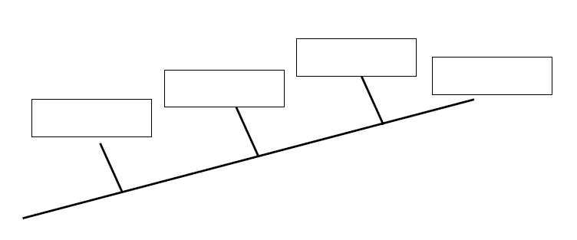

1. On the cladogram above, add traits that make the organisms different from each other.
2. According to your cladogram, which two species are more closely related: worms and spiders or worms and ants? How do you know?