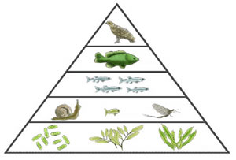
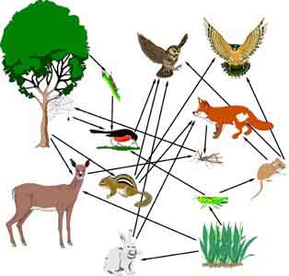
Ecology Review

Food Web, Food Chain, Energy Pyramid, Energy Transfer
What happens to energy as it moves up a level?
What is a 1st, 2nd, & 3rd level consumer?
What 2 things decrease as energy is transferred?
What is the ultimate source of energy for all ecosystems?
What type of organism must all food chains begin with?
How much energy is transferred each time it moves? Be able to calculate.
How do bears choose what types of food to eat? WHY?
Ways to save energy include:

CYCLES
Water cycle: evaporation, precipitation, transpiration. How does water move through the water cycle?
Carbon Cycle: Greenhouse effect, global warming
Nitrogen Cycle: Decomposers, Organisms that convert N2 gas into nitrates

Relationships
Mutualism
Parasitism
Commensalism
Predator/Prey
Competition

Biodiversity
Definition
Why is it important in ecosystems?
Threats to Biodiversity include:
Ecosystems with a large amount of Biodiversity are:

