Evidence for Evolution

Background:
When Charles Darwin first proposed the idea that all new species descend from an ancestor, he performed extensive amount of research to provide as much evidence as possible. Today, much evidence has been found to indicate that living things have evolved or changed gradually during their natural history. The study of comparative anatomy, embryology, fossils, and biochemistry provide evidence for evolution.

Part 1: Comparative Anatomy - Homologous Structures
These bones are formed in similar ways during embryonic development and share similar arrangements. However they have somewhat different forms and functions. They are homologous structures.
1. Carefully examine the drawings of the bones shown. Look for similarities among the various animals.
2. Color each part of the human arm a different color. (All bones of the wrist should be a single color, the bone groups of the hand should be a different single color.)
3. Color the corresponding bone in each of the other animals the same color as the human bone.

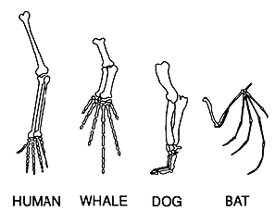

4. Describe the function of each set of bones below:
Animal | Function
Human
Whale
Dog
Bat

Part 2: Comparative Anatomy - Analogous Structures
Some apparently unrelated animals have organs with similar functions, yet are very different in structure and form. These structures are called Analogous Structures.
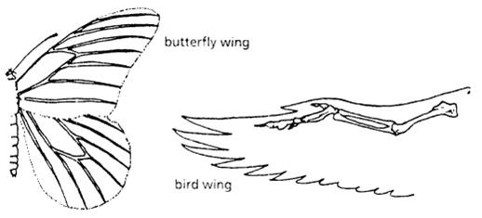

1. What is the function of each of these structures?

2. How does the form of the structures differ?

Part 3: Comparative Anatomy - Vestigial Structures
Organs or structures that have lost their function in the organism and become reduced in size (because of efficiency) are called Vestigial Structures.

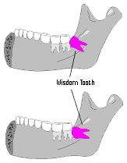
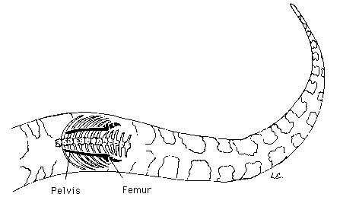
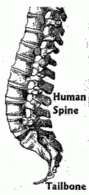
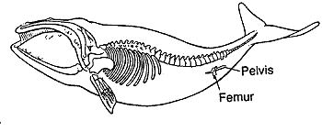

Whale pelvis and
femur (leg bone)
Snake Pelvis and
Femur (leg bone)
Human Tailbone
Human Wisdom Teeth

- Choose three of the vestigial structures shown above and describe what purpose that structure may have had in the past.

- For each structure you picked in #1, explain why you think it evolved to be vestigial.

- How do vestigial structures provide evidence for evolution?

Part 4: Embryology
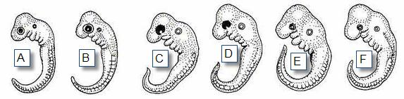
Organisms that are closely related may also have physical similarities before they are even born. Take a look at the six different embryos below:

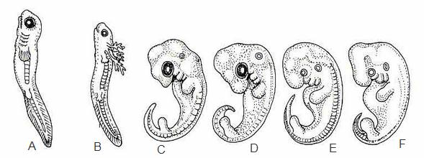
These are older, more developed embryos from the same organisms.

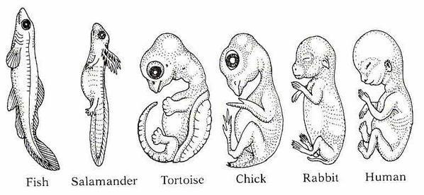
These are the embryos at their most advanced stage, shortly before birth.

B
F
E
D
C
A

1. Describe how the embryos are similar in early development and how they changed for each of these organisms from their earliest to latest stages.
Organism | Similarities in Early Development | Description of change
Fish
Salamander
Tortoise
Chick
Rabbit
Human

2. Explain how these embryos can be used as evidence of a common ancestor between these organisms.

Part 5: Fossils
Fossils are the preserved remains or traces of organisms that lived long ago. Fossils can provide clear evidence that evolution has occurred because we can see in a fossil record how a species has evolved over time.

Here is a series of skulls and front leg fossils of organisms believed to be ancestors of the modern-day horse. The earliest fossils are at the bottom and the most recent are at the top.
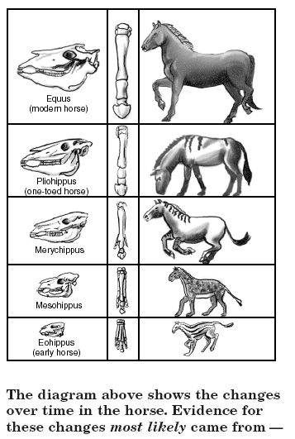
1. Look at the fossils. Give two similarities between each of the skulls that might lead to the conclusion that these are all related species.

2. What is the biggest change in the skulls that occurred from the early horse to the modern horse?

3. What is the biggest change in leg appearance that occurred from the early horse to the modern horse?

Part 6: Analysis and Interpretation
- Charles Darwin published his book On the Origin of Species in 1859. Of the different types of evidence that you have learned about, which do you think he relied on the most? Why?

- Imagine that you are talking to a friend about evolution and they say “Evolution is just a theory, it doesn’t really have any evidence to back it up.” How would you respond to them? Write at least 3 sentences.

