Human Body Systems
Using pages 144-174 in your biology book, (especially the table on pgs. 173-174) find the function(s) and the main organ(s) for the following body systems.

SYSTEM | FUNCTION(S) | MAJOR ORGANS | Role in Homeostasis
NERVOUS

CIRCULATORY

RESPIRATORY

SKELETAL

MUSCULAR

DIGESTION

ENDOCRINE

LYMPHATIC

EXCRETORY

INTEGUMENT-ARY

REPRODUC-TIVE

Additional Organ Systems Notes
Nervous System
Nerve Cells and Nerve impulses:

Axon-
Central Nervous System (CNS)-
Peripheral Nervous System (PNS)-

Nervous System Diseases:

Circulatory System
Heart and Heartbeat:
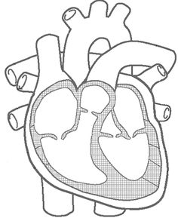

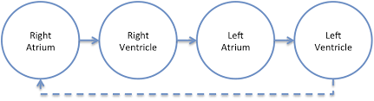
Direction of Blood Flow:

Artery-
Vein-
Capillary-

Circulatory System Diseases:

Respiratory System
How do we breathe?

Bronchi-
Alveoli-

Respiratory System Diseases:

Skeletal System
Joints:
Ball & Socket –

Hinge –

Sliding –

Ligaments-
Tendons-
Cartilage-
Bone Marrow-

Skeletal System Diseases:

Muscular System
Muscle Fibers:

Tendons -
Cardiac Muscle-
Where it is found:
Smooth Muscle-
Where it is found:
Skeletal Muscle-
Where it is found:
Voluntary Muscle-
Involuntary Muscle-

Muscular System Diseases:

