Osmosis Lab Makeup

- Use pages 128-128 in your book to define the following words:
- Diffusion:

- Osmosis:

- Hypertonic

- Hypotonic

- Isotonic

- On the following images of cells in a container of water, draw an arrow to show which direction the water will flow in each box:
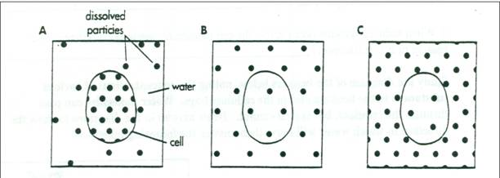

- The following picture shows 4 bags made of dialysis tubing with a sugar solution inside. Each has a different concentration of sugar. They are resting in two different solutions.
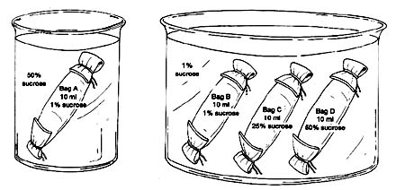
- Which bag(s) would swell
with water due to osmosis?

- Which bag(s) would shrivel
due to osmosis?

- Which bag(s) would remain
the same size?

- Which bag(s) are in a
hypertonic solution?

