**Plant Structures and Function Lab**

**Names_______________________**

**Introduction:** Just as human bodies have organ systems that move fluids, provide nutrients, and discharge wastes, plants also have systems that perform those same functions. These systems allow plants and animals to maintain homeostasis, or a constant balance. In this activity, you will look at plants using just your eyes and also under a microscope.

**Part 1-Stem parts**

1.Xylem and Phloem are like the veins of a plant. They carry water and nutrients through the stems.

2. Take the scalpel and shave a thin cross section across the bottom of the celery stem. The Xylem and Phloem are stained a color.

2. Place the cross section on the microscope and observe under low power. Draw your results below. Label the xylem and phloem. Use the picture on the lab table as a reference.

Draw your stem Cross-section here:

**Label** the **Xylem** and **Phloem**

**Use your phone to find the function of**

**Xylem:**

**Phloem:**

**Part 2: Leaves**

1. With the microscope scan the underside of the leaf and look for stomata. They look like football shaped cells inside of other cells. Use the diagram on the lab table to identify the structures. Draw one in the box:

**Use your phone to find the function of**

Draw the stomata here:

**the stomata. Write it down:**

**Part 4: Root Tip**

1. Look at the tip under the microscope and draw what you see. Look for the tip, zone of elongation and root hairs. Compare it to the diagram on the lab table. Draw what you see in the microscope.

Draw the Root Tip here:

**Use your phone to find the function of roots.**

**Write it down:**

**2.** Look at the diagram of a taproot and fibrous root system on the table. What might be an advantage and disadvantage of each?

**Advantage** **Disadvantage**

Tap Root: Tap Root:

Fibrous Root: Fibrous Root:

**Flower Structures**

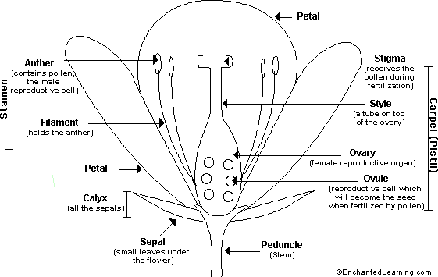

**Objectives: In this portion of the lab you will**: - *Observe the structures of a flower.*

*- Identify the functions of flower parts*.

*- Tape and label each part of the flower.*

**Procedure:**

1. Examine your flower. Use the diagram to locate the sepals and petals.

1a. How many sepals are on your flower? __________________________

1b. How many petals are on your flower?__________ What color?_________

1c. Has your flower bloomed or is it closed still? _______________________

*The Stamen and the Pistil are the reproductive parts of the flower. The Stamens produce the pollen and the Pistil produces the ovules (egg cells).*

2. Locate the stamens.

2a. How many stamens are present in your flower? _____________________

3. Locate the pistil. The stigma at the top of the pistil is often sticky. The style is a long narrow structure that leads to the ovary?

3a. How many pistils does your flower have? __________________________

3b. What color is the pistil? ________________________________________

4. Pull the stamens off of the flower and examine each one. Pollen is the powdery substance at the top.

4a. Is there pollen present? ________________________________________

4b. What color is the pollen? _______________________________________

5. Cut the pistil from the receptacle. Slice the style open with your finger nails to see the ovary, and ovule.

5a. What shape are the ovaries in? ___________________________________

5b. How many ovaries does the flower have?__________________________

5c. Which do you think produces more: pollen grains by one anther, or ovaries by on ovule? Explain. __________________________________________________________

**Stem Cross-Section Stomata**

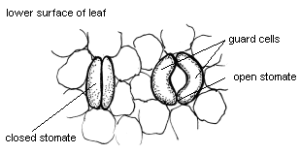

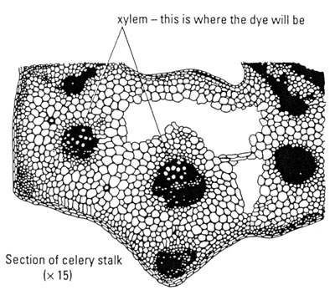

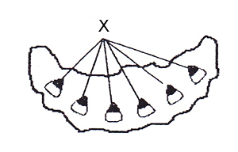

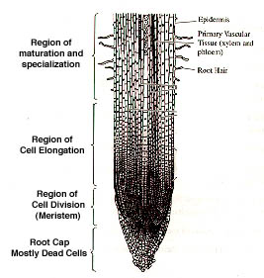**Root Tip**

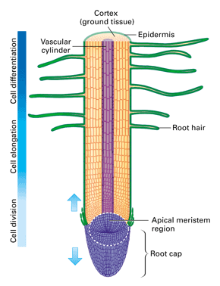

**Root Systems**

