Name_________________

Class___________________

**The Theory of Evolution**

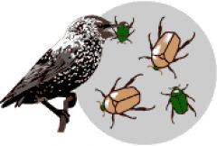**Natural Selection**

A mechanism for _______________ in populations.

In nature, organisms produce_______________ offspring than can survive.

In any population, individuals have _______________.

Individuals with certain ___________ variations ______________ in their environment, _______________ those variations to the next generation.

“________________ of the _______________”

Over time, offspring with certain __________________ make up most of the _________________ and may look entirely ________________ from their ancestors.

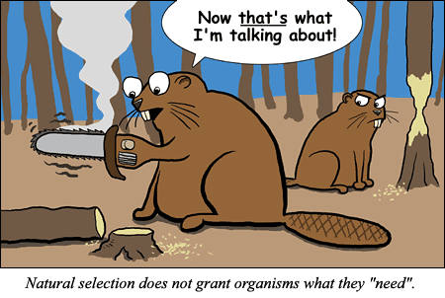Darwinian theory supported by genetics is known as the _______________ ________________.

**Adaptations**

Any __________________ that _______ in an organisms chances of survival in its ________________.

Forms of adaptation:

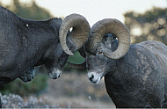1.________________ example:___________________

-_______________ example:_________________

-_______________ example:_________________

-_______________ example:__________________

2.__________________ example:___________________

3.__________________ example:___________________

Physiological adaptations are changes in an organisms ________________ _____________.

Behavioral adaptations are the things organisms do _________ _________________.

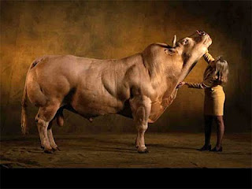**Artificial Selection/Selective Breeding**

Process of breeding organisms with ___________________ ________________ to produce offspring with _________________ __________________.

**Interpreting Evidence After Darwin**

What makes it difficult to comprehend evolutionary processes that occur over millions of years?

What is direct evidence of evolution?

Most evidence for evolution is indirect…meaning what?

_________________ are an important source of evolutionary evidence because they provide a ____________ of _____________ ______________ and evolutionary _______________.

As the fossil record becomes more __________________, the sequences of evolution become ____________.

**Comparative Anatomy**

Structural features with a ______________ evolutionary origin are called _______________ structures.

____________________ structures can be similar in _________________, in ______________ or ________.

The body parts of organisms that do not have a common evolutionary origin but are similar in _________________are called _________________ structures.

Although ________________structures don’t shed light on _____________________ relationships, they do provide _________________ of evolution.

Insect and bird wings probably _________________ separately when their ______________ ancestors adapted _________________ to similar ways of life.

**Embryology**

The science of dealing with the __________________, ___________________, ______________, and ___________ activities of embryos.

Scientists have compared similarities in the ___________, ____________, and ______________ of an embryo.

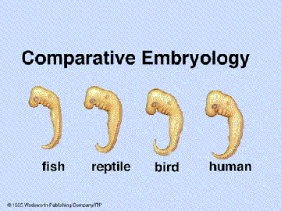The embryo of a _____________, a ___________, and a ____________ are almost ______________ at certain points in their development.

These similarities suggest ______________________ ancestry.

Many species have very similar ___________________ development.

**Comparing DNA**

Nearly all organisms share some of the same _________ base pairs.

The more base pairs that are _______ ___________, the more __________ or __________ the organisms are.

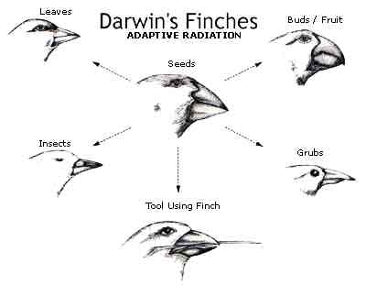**Adaptive Radiation**

Where all deriving from a ______________ ancestor have over time successfully _____________ to their environment via __________________ _________________.

**Speciation**

The evolution of a new ________________ occurs when members of ____________ populations no longer

_________________ to produce fertile offspring within their ________________ environment.

A species is defined as a group of organisms that ______________ _____________ and can _______________ to produce ___________________ offspring in nature.

Geographic isolation occurs whenever a _________________ barrier divides a population.

__________________ can result in new _______________.

**Genetic Variations**

_________________, not ___________________, evolve.

_______________ _________________ acts on the range of ____________________ of a population.

**Mutations**

Mutations: a form of ____________________ ___________________

Usually mutations on genes are ______________ to an ___________________.

Occasionally a ___________________ results in a ________________ variation and that new ____________ becomes part of the _______________________ gene pool.

**The Evolution of Species**

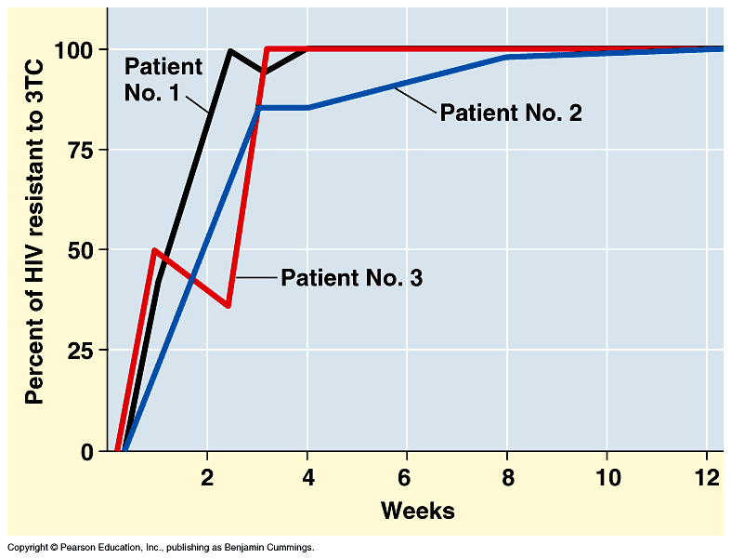

Over time, divided population may become _____________ ____________ that may no longer _____________, even if reunited.

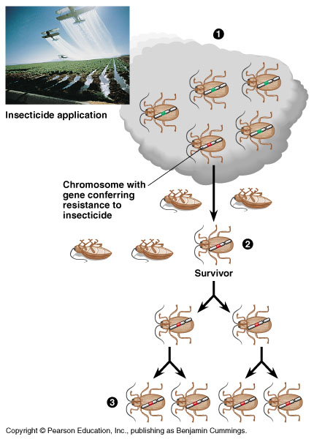

**Natural ___________________, ___________________, Genetic __________________ and __________________ all support evolution!

**Evolution: the _________________ in ________________________ over _____________.