**Name ___________________________**

**DNA Transcription and Translation**

Use the picture on the back page to answer the following questions.

1. What happens during Replication?
2. What new molecule is formed in Transcription?
3. In RNA, Thymine is replaced with ____________.
4. Write the complementary RNA strand beneath this DNA strand:

A C T T G G C A T C G A

1. Where does mRNA carry the genetic code after it leaves the nucleus?
2. _________________ is when the code on the mRNA is read to form proteins.
3. Which form of RNA transfers the correct amino acid to the protein chain?
4. What molecules are linked together to form proteins?
5. What do proteins do?

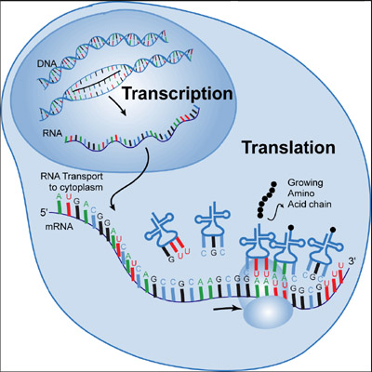

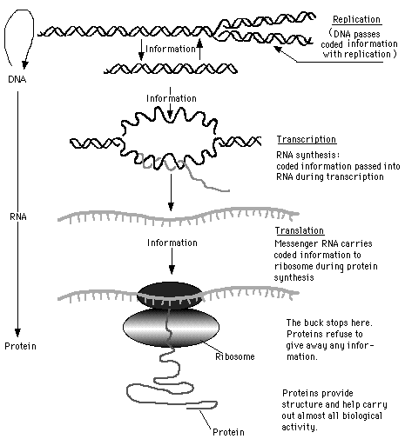

Ribosomes read the coded information on the Messenger RNA and use Transfer RNA (tRNA) to link **Amino Acids** to form proteins.

mRNA

Transcription

A messenger RNA (mRNA) copy of the DNA strand is created.

Uracil **replaces** Thymine in the DNA code. A pairs with U. G still pairs with C.

**Transcription**

* Happens in the nucleus
* mRNA is formed
* mRNA gets the code from DNA
* U instead of T
* Takes the code to Ribosome

**Translation**

* Happens in ribosome
* mRNA brings the code
* tRNA “transfers” the correct amino acid to form the protein chain
* Protein is built