VIRTUAL FROG LAB
Go to: http://www.mhhe.com/biosci/genbio/virtual_labs/BL_16/BL_16.html
Complete the activity and fill in information below.
Label the parts of the urogenital system below.
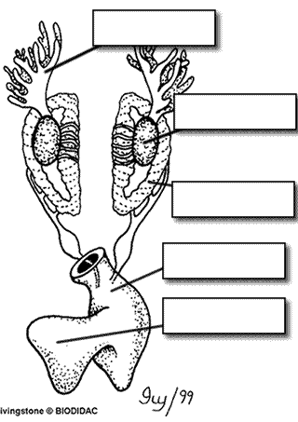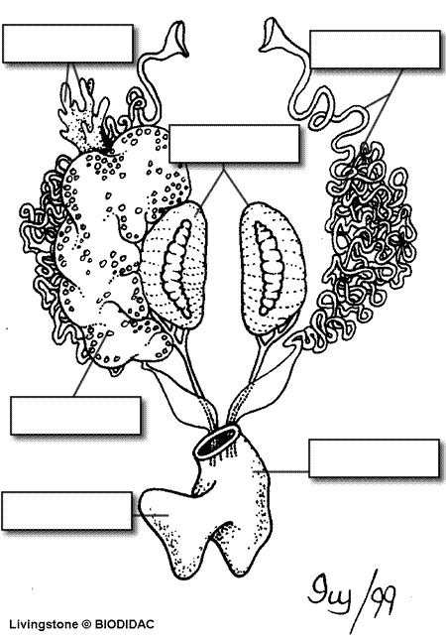
Name: _______________________________

Post Lab Questions
1. The membrane holds the coils of the small intestine together: ___________________
2.This organ is found under the liver, it stores bile: ______________________
3. Name the 3 lobes of the liver: ________________, ____________________, ____________________
4. The organ that is the first major site of chemical digestion: _______________________
5. Eggs, sperm, urine and wastes all empty into this structure: _____________________
6. The small intestine leads to the: __________________________
7. The esophagus leads to the: _________________________
8. Yellowish structures that serve as an energy reserve: ____________________
9. The first part of the small intestine(straight part): _______________________
10. After food passes through the stomach it enters the: ____________________
11. A spiderweb like membrane that covers the organs: ______________________
12. Regulates the exit of partially digested food from the stomach: ________________
13. The large intestine leads to the __________________
14. Organ found within the mesentery that stores blood: _____________________
15. The largest organ in the body cavity: _____________________
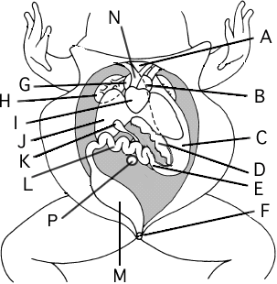

Label the Diagram
A. __________________________________
B. __________________________________
C. __________________________________
D. __________________________________
E. __________________________________
F. __________________________________
G. __________________________________
H. __________________________________
I. __________________________________
J. __________________________________
K. __________________________________
L. __________________________________
M. __________________________________
N. __________________________________

